Renewable by Nature Capital Limited
(Incorporated in the Republic of South Africa)
(Registration number 2018 / 383003 / 06)
(FSP number 49 781)
(“RBNC” or “the Company”)



A Public Company as defined in terms of Companies Act 71 of 2008.

PROSPECTUS

A general public offer to subscribe for 10 000 Ordinary D-Shares at an issue price of R5 000 per Ordinary share
Opening date of the Offer 1 October 2025 – 31 December 2025

Renewable by Nature Capital Limited
(Incorporated in the Republic of South Africa)
(Registration number 2018 / 383003 / 06)
(FSP number 49 781)

PROSPECTUS
The definitions and interpretations commencing on page 7?? of this document apply to this entire document, except where the context indicate contrary intention.
An investment in Renewable by Nature Capital Limited (‘RBNC’) is speculative and high-risk.
- The Ordinary Shares are unlisted, which means there is no readily available secondary market for these securities. Investors may not be able to sell their shares easily or at all.
- Investors may lose part or all of their capital, and there is no guarantee of returns or dividends.
- The success of RBNC depends on factors outside its control, including regulatory changes, currency fluctuations, project execution risks, and counterparty performance.
- These shares are suitable only for investors with a high tolerance for risk, a medium- to long-term investment horizon, and the ability to bear a total loss of investment.
Prospective investors should not invest unless they can afford to lose the entire amount invested.
This Prospectus includes forward-looking statements. Forward-looking statements are statements that include, but are not limited to, any statements regarding the future financial position of the Company and its future prospects.

These forward-looking statements have been based on current expectations and projections about future results which, although the Directors believe them to be reasonable, are not in any manner warranty or guarantee of future performance.

Risk factors which may influence the Company's actual results, performance or achievements to deviate materially from any future results, performance or achievements expressed or implied by it in the forward-looking statements include, among other things, economic decline and foreign currency risk. Risk factors are described in Annexure 1 of this Prospectus.

The Directors and officers, whose names are set out in this document, accept full responsibility, collectively and individually, for the accuracy of the information given herein and certify that, to the best of their knowledge and belief, no facts have been omitted which would make any statement false or misleading, they have made all reasonable enquiries to ascertain such facts and that this Prospectus contains all information as may be required by law.

The Advisors, whose names are included in this Prospectus, have given and have not, prior to registration, withdrawn their written consent to the inclusion of their names in the capacities stated and, where applicable, to their reports being included in this Prospectus.
Auditors   | Property Advisors   | Reporting Accountants  
Attorneys   | Compliance Officer   |   Energy Advisors

This Prospectus is only available in English. Copies of this Prospectus may be obtained during normal business hours from the registered office of RBN Capital Limited at their respective address set out in the “Corporate Information and Advisors” section of this Prospectus from the date of issue.
Corporate Information and Advisors
Business & Registered Office Address | Technical Advisors
Renewable by Nature Capital Limited  Registration Number: 2018/383003/06  FSP Number: 49 781  SARS Ref: 9342475192  302 Aquila Avenue  Waterkloof Ridge  Pretoria,  0081  Tel: 082 804 0088 | CFJM Solutions (PTY) Ltd  Registration Number: 2012 / 177574 / 07  26 Suikerbos street  Potchefstroom  North West  2520  POSTNET Suite 113  Private Bag X288  Potchefstroom  2520  Tel: 082 440 8420
Attorneys | Compliance Officer
Gioia Engelbrecht Incorporated  Practise Number: 65833  Pretoria Office  Office Co - 2nd Floor, Walker Creek Office Park  Building, 2, 90 Florence Ribeiro Ave,  Muckleneuk,  Pretoria.  Tel: 082 514 1903 | Moonstone Compliance (PTY) Ltd  Registration Number: 2002/020736/07  FSB Practise Number: 188  Physical Adress: 25 Quantum Street, Technopark, Stellenbosch, South Africa  Postal Address:25 Quantum Street, Technopark, Stellenbosch, South Africa  Tel: +27218838000
Auditors, and Tax Advisor | Reporting Accountants
Kreston Pretoria  Practise Number: 90094  Crestway Office Park  Block E  20 Hotel Street  Persequer,  Pretoria  0060  PO Box 1569  Garsfontein East  0060  Tel: 012 993 9500 | Carmen Marais Chartered Accountants Inc.  Practice Number: 31837618  Unit 49, Leisure Bay Estate,  Bayside Road,  Erasmus Park,  Pretoria,  0181  Unit 49,  Leisure Bay Estate,  Bayside Road,  Erasmus Park,  Pretoria,  0181  Tel: 082 903 5857

General Statements

The Directors recommend that you consult with your own independent legal, tax, accounting, investment or other relevant advisors when contemplating any investment decisions described in this document in order to err on the side of caution.

The information contained herein has been prepared to assist in forming an initial view of the Offer. The document does not purport to contain all the information that an investor may require nor is it intended to replace any form of legal, investment, tax, or technical due diligence process. The content hereof may not be used and/or relied upon for any purpose other than to evaluate whether you wish to participate in the Offer.

In the event of any conflict or inconsistency between the terms of this Prospectus and RBNC’s MOI, the terms of the MOI shall prevail. In the event that it is necessary to amend the MOI in order to procure the enforcement of any of the provisions of this Prospectus or to carry into effect the intent of this Prospectus, the Directors will use all reasonable endeavours to procure that the MOI is so amended.

Disclaimer

The contents of this Prospectus do not constitute and should not be construed as investment, tax, legal, accounting and/or other advice. For advice on these matters we recommend that you should consult your preferred investment, tax, legal, accounting and/or other advisor about any information contained in this Prospectus.

Warning

An investment into RBNC is speculative by nature and prospective subscribers should refer Annexure 1 of this Prospectus concerning the potential risks.

Table of Contents
Definitions and Interpretations 7
PROSPECTUS 10
SECTION 1 - INFORMATION ABOUT RBNC 10
SECTION 2 – DETAILS OF THE OFFER 21
SECTION 3 - STATEMENTS AND REPORTS RELATING TO THE OFFER 24
SECTION 4 - INAPPLICABLE TO PROSPECTUS 28
ANNEXURE 1 - Risk Factors 29
ANNEXURE 2 - Appointment, qualification, remuneration and borrowing powers of directors 31
ANNEXURE 3 – Directors service contracts 32
ANNEXURE 4 – FSCA License 33
ANNEXURE 5 - King Code on Corporate Governance 37
ANNEXURE 5 – King IV™ on Corporate Governance 37
1. Board of Directors 37
2. Board Committees 37
a) Audit & Risk Committee 37
b) Remuneration & Nominations Committee 37
c) Investment Committee 37
3. Risk & Opportunity Governance 37
4. Ethics & Responsible Corporate Citizenship 37
5. Technology & Information Governance 38
6. Stakeholder Relationships 38
7. Compliance with King IV™ 38
ANNEXURE 6 – FSB Report 39

Definitions and Interpretations

In this Prospectus, unless the context indicates otherwise, reference to the singular shall include the plural and vice versa, words denoting one gender include others, expressions denoting natural persons include juristic persons and associations of persons and the words in the first column have the meanings stated opposite them in the second column as follows:

“Act” | The Companies Act, No. 71 of 2008, as amended;
“Advisors” | Gioia Engelbrecht Incorporated, Moonstone Compliance, Kreston Auditors, Carmen Marais Chartered Accountants Inc., DDP Valuers,
“Application Form(s)” | The application form in respect of the Offer, which is attached to, and forms part of this prospectus and which must be completed by all prospective investors;
“Attorneys” | Gioia Engelbrecht Incoporated, full details of which are contained in the Corporate Information and Advisors section of this Prospectus;
“Auditors” | Kreston Pretoria, full details of which are contained in the Corporate Information and Advisors section of this Prospectus;
“Board” | the directors of the Company from time to time, which, as at the Last Practicable Date, comprises the persons listed in section 1, paragraph 2 of this Prospectus;
“Business Day” | any day other than a Saturday, Sunday or statutory holiday in South Africa;
“Closing Date” | which may be amended by the Company by way of an announcement released on its website;
“Company” | Renewable by Nature Capital Limited, registration number: 2018 / 383003 / 06 a public company incorporated under the laws of South Africa, full details of which are contained in the Corporate Information and Advisors section of this Prospectus;
“Company Secretary” | At the time of drafting this document the company secretary has not been appointed but will be concluded prior to end of the offer period (RETHA??);
“Connected Person(s)” | connected person as defined in section 1 of the Income Tax Act, No. 58 of 1962;
“Directors” | the directors of the Company from time to time, which, as at the Last Practicable Date, comprises the persons identified section 1, in paragraph 2 of this Prospectus;
“EPC” | Engineering, Procurement, and Construction a term used to refer to a company that provides engineering and design, equipment procurement and delivers the functioning asset to the client;
“FAIS” | Financial Advisory and Intermediaries Services Act, No. 37 of 2002;
“FSCA” | Financial Sector Conduct Authority, established in terms of the Financial Sector Regulation Act (FSR Act) of 21 August 2017;
“Gross Investment” | the gross amount subscribed for Shares paid by Investors;
“Income Tax Act” | the Income Tax Act, No. 58 of 1962, as amended, consolidated or re-enacted from time to time and including all schedules thereto;
“Investment Portfolio” | the Portfolio of investments created by investing the proceeds raised from the issue of Shares pursuant to the Offer;
“Investor(s)” | an individual, trust, company, or other legal entity who subscribes for Shares;
“Manager” | RBNC is a self-managed fund by the Directors appointed by the Ordinary-A shareholders as set out in the MOI unless where a specific management agreement have been entered into;
“MOI” | the memorandum of incorporation of the Company, as amended from time to time;
“Money Laundering Regulations” | the Money Laundering Regulations 2007;
“Off Taker” | the counter party to the PPA;
“Offer” | the offer for subscription for 10 000 Ordinary D-Shares, the terms of which are set out in this Prospectus, targeted at retail investors to include high net worth individuals, trusts and companies seeking to gain from the benefits of this portfolio;
“Offer Period” | the period from 1 October 2025 to 31 December 2025;
“Offer Price” | R5 000 per Share
“Ordinary Shares” | Ordinary Shares in RBNC as described in the MOI;
“POPI” | the Protection of Personal Information Act, No. 4 of 2013;
“PPA” | Power Purchase Agreement setting out the parameters that facilitate the sale of electricity by RBNC or one of its subsidiaries to the Off-Taker;
“Prospectus” | this prospectus and its annexures, issued on 1 October 2025;
“Ordinary Shares” | ??
“Qualifying Company” | a company or project that satisfies the minimum requirements of RBNC Investment Committee;
“Qualifying Investment(s)” | an investment in the shares of a Qualifying Company;
“Qualifying Shares” | an equity share issued to RBNC by a Qualifying Company;
“RBNC” | Renewable by Nature Capital Limited, registration number: 2018 / 383003 / 06 a public company incorporated under the laws of South Africa, full details of which are contained in the Corporate Information and Advisors section of this Prospectus;
“Register” | the register of Shareholders of the Company;
“SARS” | the South African Revenue Service;
“Shareholder” | a holder of Shares;
“Shares” | Ordinary Shares;
“SME” | a small or medium sized enterprise;

Renewable by Nature Limited
(Incorporated in the Republic of South Africa)
(Registration number 2018 / 383003 / 06)
(FSP number 49 781)
(“RBNC” or “the Company”)

PROSPECTUS

SECTION 1 - INFORMATION ABOUT RBNC

NAME, ADDRESS, AND INCORPORATION (reg 57)

  - Renewable by Nature Capital Limited (Registration number 2018/383003/06) was incorporated as a private company on 6 July 2018. (reg 57 (1) (a) and (c)).

  - The Company converted from a private company to a public company on 19 November 2019. (reg 57 (1) (a) and (c)).

  - The Company removed the Ring Fenced Status during October 2023

  - The Company’s registered office and primary place of business is the registered office and primary place of business of the Company is at 302 Aquila Avenue, Waterkloof Ridge, Pretoria, 0081. (reg 57 (1) (b)).

  - As at the Last Practicable Date, the Company’s subsidiaries include PHTN Energy (PTY ) Ltd 2021/884894/07. The Company’s holding company is RBN Holdco (PTY) Ltd 2023/854598/0 (reg 57 (3)).

  - The purpose of this Prospectus is to raise capital to expand the Company’s investment activities and take advantage of its strong pipeline of opportunities.

DIRECTORS, OTHER OFFICE HOLDERS AND MATERIAL THIRD PARTIES (reg 58)

  - The Board currently comprises of One Executive Director and one non-Executive Director. Details relating to the management of the Company are set out in the document below.

  - The full names, business addresses, qualifications, positions and experience of the directors and prescribed officers, all of whom are South African citizens, are set out below: (reg 58 (2)(a))

Name | Arno Lawrenz (Arno Lawrenz) (reg 58 (2)(a)) (age: 57)
Business Address | 31 Invermark Crescent, Higgovale, Cape Town, 8001 (reg 58 (2)(a))
Qualification | Chartered Financial Analyst (CFA), Bachelor of Science Statistics (Honours) (reg 58 (2)(a))
Position | Non-Executive Director (reg 58 (2)(a))
Experience | Mr. Arno Lawrenz, CFA currently holds the position as Chief Investment Officer at Sasfin Asset Managers. He previously served as the Chief Investment Officer at Atlantic Asset Management (Pty) Limited. Previously, he was the Head of Fixed Interest at Old Mutual Investment Group (Pty) Limited. Mr. Lawrenz joined Old Mutual Asset Managers in July 2003. He was the Head of Fixed Interest at Coronation Fund Managers and a Portfolio Manager of Coronation's strategic income, bond, income, and money market funds Mr. Lawrenz is a C.F.A. charter holder. He earned a B.Sc. Honours degree. Mr. Lawrenz also completed his Re 1,3,5 examinations

Name | Pieter Willem Botes (Pieter Botes) (reg 58 (2)(a)) (age: 45)
Business Address | 302 Aquila Avenue, Waterkloof Ridge, Pretoria, 0181 (reg 58 (2)(a))
Qualification | Bachelor of Commerce: Financial Management, Master of Business Leadership (MBL) (reg 58 (2)(a))
Position | Executive Director (reg 58 (2)(a))
Experience | Mr. Pieter Botes, is the founder of the RBN Group of companies and serves as Executive on all the boards. He previously held a position as Senior Manager at Deloitte in the Global Investment and Innovation Incentives Division. Pieter started his career at Investec and RMB where he was a portfolio manager within the private Banking sphere focussing on structured lending and product development. He has held positions as Investment Manager with the Pan-African Impact Investor Grofin and as Portfolio Manager at National Treasure the Jobs Fund looking after a multi-billion rand portfolio.

  - Company advisors and Company Secretary (reg 58(2) (b))

    - The names and business addresses of the Advisors are set out in the “Corporate Information and Advisors” section of this Prospectus. (reg 58(2) (b) (i) and (ii))

    - The Company Secretary and Advisors other than disclosed in this Prospectus, do not have any interest in the Company as at the Last Practicable Date.

  - Additional information relating to Directors

    - Directors shall be elected by an ordinary resolution of the shareholders at a general or annual general meeting. (reg 58 (3) (a))

    - Annexure 2 contains the following additional information in respect of the Directors: (reg 58 (3) (b))

      - borrowing powers of the Company exercisable by Directors, which have not been exceeded or varied since the Company’s incorporation, and how such borrowing powers can be varied; (reg 58 (3)(c))

      - directors and prescribed officers’ remuneration policy; and

      - retirement and appointment of directors. (reg 58 (3) (a))

    - All Directors have a term of office of five years.

    - The Directors’ and Officers’ emoluments are set out below:

Name of Director | Officer Position | Fees
Arno Lawrenz | non-executive Director | R0
Pieter Botes | executive director, member of the audit committee and member of the investment committee | R850 000 per annum

  - Management of the Company (reg 58 (3) (d))

    - RBNC is a self-managed fund as set out in the MOI, with the Ordinary-A shareholders fulfilling the management function.

    - RBNC encompasses an experienced management team with extensive private equity, private company and commercial experience, including:
      - originating, evaluating and selecting suitable investment opportunities;

      - providing post investment management services; and

      - identifying and implementing exit opportunities.

    - The manager is entitled to a once-off capital raising fee of 3% of funds raised (excluding VAT) for Ordinary Shares issued. (reg 58 (d) (iii). This may be waived at the sole discretion of the Board.

    - The manager is entitled to an ongoing management fee of 3% (excluding VAT) starting from the date of subscription and until the original investment has been repaid. (reg 58 (d) (iii)

    - The manager is entitled to a percentage of no less than 20% of trading profits after other Ordinary shareholders have received dividends and / or other returns and based on sole discretion of the Board determined from time to time. (reg 58 (d) (iii)

    - Trading of assets 3% (platform Fee)

    - The Manager will carry the costs incurred in evaluating investment opportunities not implemented. (reg 58 (d) (iii))

  - Directors’ Declarations

    - None of the Directors of the Company have been declared bankrupt, insolvent or have entered into any individual voluntary compromise arrangements, or has been publicly criticised by any statutory or regulatory authorities, including recognised professional bodies, or being disqualified by court from acting as a director of a company or for acting in the management or conduct of the affairs of the Company, or has been convicted of any offense involving dishonesty.

    - No payment has been made to any Director at the Last Practical Date, to induce him to become a director or in connection with the promotion or formation of the Company.

    - Formal letters of appointment have been entered into with all Directors of the Company and are available for inspection at the registered offices of the Company.

HISTORY, STATE OF AFFAIRS AND PROSPECTS OF RBNC

  - History of the Company (reg 59)

    - Overview (reg 59(2) (b))

      - RBNC was incorporated as a private company on 6 July 2018. (reg 59(3) (a) (i) and (ii))

      - The company converted from a private company to a public company on 19 November 2019. (reg 59(3) (a) (i) and (ii))

      - The primary investment objective of the Company is to secure a portfolio of income producing assets.

    - Nature of business

      - RBNC is a licensed Financial Services Provider in terms of Section 8 of FAIS under license number 49 781. A copy of the FSCA license is contained in Annexure 4 of this Prospectus.

      - RBNC does not fall within the ambit of the Collective Investment Schemes Control Act, No. 45 of 2002.

  - Material changes (reg 59(3) (b))
There have been no material changes in the business of the Company since its conversion from a private company to a public company on 19 November 2019.

Prospects (reg 59 (3) (c) (i))

    - Investment Objectives

        - RBNC aims to acquire and / or develop a portfolio of income producing assets.

    - Investment Strategy

      - RBNC acquires shares in companies or projects that develops income generating assets such as Solar PV projects or Property Investments.

      - The Solar PV or Property projects that will be considered by the investment committee are those that meet the return relative to duration of the off-take or rental agreement.

    - Investment Process

      - RBNC Investment Committee, will apply comprehensive investment processes in considering investments and will conduct due diligence investigations before recommending any potential investment to the Board of RBNC.

      - RBNC due diligence (“DD”) process comprise of an in-depth Due Diligence which will include a comprehensive assessment of the technical feasibility, off takers needs, capex requirements, cash flows, profitability, legislative requirements, credit worthiness of the off taker and sustainability of the off taker.

      - The results of the Due Diligence will be presented to the Investment Committee for final decision making, where after the relevant agreements will be drafted.

    - Post investment management

      - The Board’s post investment plan is to mitigate risk, and as such will on a regular basis conduct audits on the performance and output of each project. These audits will be conducted to ensure that all power installations are performing optimally and remain optimised for maximum electrical output.

      - RBNC will oversee:

- the adherence of off takers to the PPA and or rental income;
- the maintenance of the solar installations or the appointment of a service provider to do so;
- the solar installations with adhere to all legislation and bylaws to which they have to comply; and
- any visual communication applied to the structure or equipment of which the solar installation comprises.

    - Investment Mandate

      - Capital raised will be invested, in terms of its investment mandate or mutually agreed to by the Investor, as adopted by the Board which currently is set out below. The Board reserves the right to amend the investment mandate from time to time.
      - An investment in RBNC should be considered as a High-Risk, medium-to-long term investment.

    - Exit strategies
The RBNC Board will continuously evaluate various exit mechanisms for its investments. These would include but are limited to:

  - Sale of underlying subsidiary/ies;
  - Listing of RBNC
  - Sale of future cashflows of PPA’s in Qualifying Companies
Investment Type | Percentage of Fund (%) | Targeted IRR Return (%) | Average Time Frame of Investment
Cash on Hand, call and fixed deposits | 0 - 100 | 25 | 7-10 years
0 – 11 year PPA’s | 0 – 80 | 17 | 7-10 years
12 – 15 year PPA’s | 0 – 80 | 18 | 7-10 years
16 – 20 year PPA’s | 0 – 80 | 19 | 7-10 years
Non-Qualifying Companies | 0 - 20 | 15 | 7-10 years

    - RBNC’s Investment Committee (reg 58 (3) (d))
The Investment Committee comprises of a minimum of two members. The primary members of the Investment Committee are Pieter Botes and Chris Delport. Decisions are made on a majority vote by members. The committee has the right to co-opt appropriately skilled parties as and when required.

    - RBNC’s Deal flow
RBNC is currently in negotiations to develop the following solar installations through its Ordinary D-Shares.

Client Location | PPA per kWh | System Size MWp | System Value
Sun Frontier (BBRU) | R2.75+ | 4 | R45m
Small Scale Embedded Generating Assets | R3.00+ | 8 | R80m
Mozambique JV | R1.27+ | 23 and 30 (53) | R1.2b
Total |  | 12 | R1 325b

    - Directors’ opinion regarding prospects (reg 59 (3) (c))
The Directors are of the opinion that RBNC has good prospects of achieving its investment mandate based on the following:

- an experienced, well-balanced, innovative and motivated management team;
- a well-developed pipeline of investment opportunities;
- an extremely experienced and diversely skilled board;
- a rigid due-diligence and selection process; and
- active post investment management;

    - State of affairs of the Company (reg 59(3) (d))

      - The unaudited pro-forma income statement and balance sheet are provided for illustrative purposes only to provide information about how the private placement may have impacted on the Companies results and financial position. Due to the nature of the unaudited pro-forma financial information, it may not give a fair presentation of the Companies results and financial position after the private placement. The historic and forecast statement of profit and loss and other comprehensive income for the year ended on 28 February. The directors' forecasts are based on the targeted capital being raised of R50 00 000 (Fifty Million Rand) through the issue of 10 000 (Ten Thousand) Ordinary Shares being raised by 31 December 2025.

      - The pro-forma Statement of Financial Position has been prepared assuming the private placement took place on 1 October 2025 and the pro forma Statement of Comprehensive Income has been prepared assuming the private placement took place on 1 October 2025.

Statement of Comprehensive Income
 |  | Unaudited 29-Feb-2024
Revenue |  | -
Fee Income |  | 2 000 000
Sales |  | 300 000
Income From subsidiaries |  | 2 400 000
Cost of Sales |  | -
Gross Profit |  | R4 700 000
Expenses |  | 2 288 000
Audit Fees |  | 30 000
Bank Charges |  | 10 000
Compliance Fees |  | 12 000
Insurance |  | 100 000
Secretarial Fees  FSCA Subscription  Director Emoluments |  | 24 000  12 000  2 000 000
Interest Income |  | 0
Total Interest |  | 0
Profit Before Tax |  | 2 412 000
Taxation |  | 675 360
Profit After Tax |  | 1 736 640
Share Capital of the Company
Total Ordinary A-Shares |  | 10 000
Earnings per Share |  | 174

    - Pro forma statement of financial position before and after the Offer
The unaudited statement of financial position of RBNC at 29 Feb 2024, assuming the
Offer is fully subscribed are set out below.

Statement of Financial Position
 |  | Unaudited 28-Feb-2024
Asset
Non-Current Assets |  | 10 500 000
 |  | 10 500 000
Current Assets |  | 100 000
Trade and Other Receivables |  | 0
Cash and Cash Equivalents |  | 100 000
Total Assets |  | 10 600 000
Equity and Liabilities
Equity
Stated Capital |  | 10 600 000
Ordinary Shares |  | 10 600 000
Retained Income |  | -
Total Equity |  | 10 600 000
Liabilities
Current Liabilities |  | -
Current Taxes Payable |  | -
Trade Payables |  | -
Total Equity and Liabilities |  | 10 600 000
Share Capital of the Company
Number of Shares Authorised – Ordinary A-Shares |  | 10 000
Total Ordinary A-Shares Issued |  | 10 000
NAV Per Share |  | 1060

Note 1:
Stated Capital – Ordinary Shares
Assuming 500 Ordinary B-Shares have been issued at R15 000 per share. R7 500 000

    - Principal immovable property owned (reg 59(3)(e)

      - There are no immovable properties owned by the Company directly only via subsidiaries.

    - Capital commitments, lease payments and contingent liabilities (reg 59(3)(f))

      - Capital commitments
At the Last Practicable Date, the Company has made no material commitments for capital expenditure
for the acquisition, construction or installation of any buildings, plant or machinery.

      - Contingent liabilities
At the date of this Prospectus, the Company has no material contingent liabilities.

    - Turnover, profit and loss and dividend policy (reg 59(3) (g))

      - Refer to paragraph 3.3.11 for the revenue, profits and losses of the company since its date of incorporation. (reg 59(3) (g) (i) and (ii))

      - The report by the Auditor in terms of Regulation 79 of the Companies Act is reflected as Annexure 6.

      - RBNC has not paid any dividends at any time prior to the Last Practicable Date. (reg 59(3) (g) (iii))

      - Surpluses on realisation of investments will ordinarily be distributed to shareholders by way of dividends as determined by the Board from time to time. Dividends paid will be subject to Dividends Tax as applicable.

SHARE CAPITAL OF THE COMPANY (reg 60)

  - The authorised and issued share capital of the Company before and after the offer is set out below. (reg 60(a)

 | 1-Jan-2022 | 1-Oct-2023
Number of Authorised Shares
Ordinary A-shares  Ordinary B-shares | 10 000  10 000 | 10 000  10 000
Ordinary C-shares | - | 10 000
Ordinary D-shares | - | 10 000

 | 1-Jan-2022 | 1-Oct-2023
Number of Issued Shares
Ordinary A-shares  Ordinary B-shares | 1 000  1 000 | 9 500  3 000
Ordinary C-shares | 10 000 | 10 000
Ordinary D-Shares | 10 000 | 400

The authorised and unissued shares are under the control of the Directors, subject to the provisions of Section 41 of the Act.

None of the Ordinary Shares have any conversion or redemption rights. All Ordinary Shares participate equally in dividends declared by the Board.

The Shares held by the Directors are set out in paragraph 8.2 (reg 60(a) (iii)).

Details of any alterations to the share capital of the Company from the date of incorporation of the Company is available upon request. (reg 60(b))

OPTIONS OR PREFERENTIAL RIGHTS IN RESPECT OF SHARES (reg 61)

The Company is not party to any contract or arrangement (or proposed contract or arrangement), whereby an option or preferential right of any kind is (or is proposed to be) given to any person to subscribe for any shares in the Company.

COMMISSIONS PAID AND PAYABLE IN RESPECT OF UNDERWRITING OF SHARES ISSUES (reg 62)

There have been no commissions paid or payable in respect of underwriting by the Company from its incorporation date up to the Last Practicable Date.

No other commissions, discounts or brokerages have been paid nor have any other special terms been granted in connection with the issue of shares by the Company.

MATERIAL CONTRACTS (reg 63(1) (a) (b), 63(2))

Save for the Directors service agreements, there are no contracts entered into by the Company for directors’ and managerial remuneration, royalties, secretarial and technical services, or material contracts other than in the ordinary course of business entered into by the Company within the last two years.

All the material contracts concluded by the Company are open for inspection at its registered address during normal office hours from the date of issue of this Prospectus up to and including the Closing Date.

INTEREST OF DIRECTORS AND PROMOTERS (reg 64)

No consideration, has been paid, or agreed to be paid to:

any Director or related party;

another company in which a Director has a beneficial interest or of which such Director is also a director; or

any partnership, syndicate or other association of which the Director is a member to induce the Director to become a director, to qualify as a director or for services rendered by the director or by a company, partnership, syndicate or other association, in connection with the promotion or formation of the Company. (reg 64(2) (a))

At the last practical date, the Directors held shares in the company.

The Directors have no interests in material contracts or transactions other than that disclosed in this Prospectus.

LOANS (reg 65)

At the Last Practical Date, RBNC has no material loans payable and had no material loans advanced to any party apart from a Director loan.

SHARES ISSUED OTHERWISE THAN FOR CASH (reg 66(a), 66(b))

There have been no Shares issued other than for cash since the Company’s incorporation.

PROPERTY ACQUIRED OR TO BE ACQUIRED (reg 67)

Since incorporation of the Company and up to the date of this Prospectus, the Company did not acquire any immoveable property or fixed assets.

AMOUNTS PAID OR PAYABLE TO PROMOTERS (reg 68)

A capital raising fee of 3% is payable to the promoters on all Ordinary Shares subscribed for in terms of this Offer. In the last three years, a total amount of R50 000 has been paid to the promoters as a capital raising fee.

PRELIM INARY EXPENSES AND ISSUE EXPENSES (reg 69)]

An amount of R 200 000 has been budgeted for the expenses of this Offer on full subscription, excluding capital raising fees.

These expenses (VAT exclusive) are estimated and comprise the following:
Service | Service Provider | R
Preparation of Prospectus | SF Inc. | R 36 900
Preparation of Statutory Documents | SF Inc. | R 29 520
Corporate Finance | Kreston SA | R 29 520
Registration of Prospectus | CIPC | R 2 583
Reporting of Accountants Report | Kreston SA | R 7 380
Review of Prospectus by Tax Practitioner | Kreston SA | R 11 070
Review of Prospectus by Compliance Officer | Masthead | R 11 070
All FICA related documents | BLCS | R 9 225
Auditors Report | Kreston SA | R 1 845
Secretarial Fees | BLCS | R 11 070
Auditors Report | Kreston | R 1 845
Accounting Services | Multifin Financial Solutions | R 11 070
IT and Software | Various | R 36 900
Total |  | R200 000

In the last three years, there have been no preliminary and issue expenses incurred by the company.

SECTION 2 – DETAILS OF THE OFFER

PURPOSE OF THE OFFER (reg 70(a))

The purpose of the Offer is:

to expand the capital base of the Company;

to increase the issued capital of RBNC to enable it to invest in Qualifying Companies;

to invite members of the public, financial institutions, pension funds, and business associates of RBNC to invest directly in the Company;

to broaden the shareholder base of RBNC;

to enhance the Company’s profile as a leading Investment Company; and

to fund the growth of the Company.

Any amounts raised in excess of the projected issuing expenses, will still achieve the Company’s goal to increase its capital base. (reg70 (b))

SALIENT DATES (reg 71)

The dates and times for the opening and closing of the offer is set out below:

Details | Date
Opening date of the offer (9:00)  Expected Closing Date of the Offer (17:00) | 1 October 2025  31 December 2025

PARTICULARS OF THE OFFER (reg 72)

The Offer comprises:

an offer to the public to subscribe for 10 000 Ordinary Shares of at a price of R5 000 per share, each having 1 vote per share, and being of the same class as the existing shares in issue; and

Application may be made by completing the "Mandate and Application Form" in this Prospectus.

The Directors have resolved, via the required resolutions, authorisations and approvals, to issue 10 000 Ordinary Shares of at R5 000 per share in terms of the Offer. The Directors consider this price to be justified by the prospects of the Company.

Applications for the subscription may only be made on the forms which are enclosed with this Prospectus. Applications are irrevocable and may not be withdrawn once received by RBNC.

Mandate and Application forms must be completed in accordance with the provisions of this Prospectus and the instructions as set out in the Mandate and Application form.

Applications must be for a minimum of 1 (one) Ordinary B-Shares.

All application forms completed in accordance with the provisions of this Prospectus and the instructions set out on the Mandate and Application form, should be delivered to:

Email address:
pieter@rbn.co.za

Physical address:
302 Aquila Avenue, Waterkloof Ridge, Pretoria, 0081

Registered mail:
302 Aquila Avenue, Waterkloof Ridge, Pretoria, 0081

Applications will be regarded as complete once payment has been received. Payment may be made by bank guaranteed cheque (crossed “not transferable”) or banker’s draft or electronic transfer into the following bank account:

Account Name: Renewable by Nature Capital
Bank Name: First National Bank
Branch Name: Woodmead
Branch Code: 250 955
Account Number: 627 815 163 92

Applications will be irrevocable once received by RBNC. No receipts will be issued for applications and/or payments received.

RESERVATION OF RIGHTS

The Directors of RBNC reserve the right to accept or refuse any application(s), either in whole or impart, or to abate any or all application(s) in such manner as they may, in their sole and absolute discretion, determine.

The Directors of RBNC reserve the right to accept applications for less than 1 share per application at their absolute and sole discretion.

RESULTS OF ALLOCATIONS

Investors will be notified of the allocation of shares within seven days of the closing date by way of electronic communcation.

Over Subscriptions

In the event of any Offer application being rejected or accepted for a lesser number of Shares than applied for, any surplus application monies received will be refunded by RBNC within seven days of the Closing Date.

Issue of Shares

All Ordinary Shares to be issued in terms of the Offer will be issued at the expense of RBNC.

Issues in the past three years (reg 72(2) and (3))

1100 Ordinary B-Shares have been issued since the incorporation of the Company leaving 8900 Ordinary B-Shares Available.

MINIMUM AND MAXIMUM SUBSCRIPTIONS IN TERMS OF THIS OFFER (reg 73)

The minimum amount to be raised in terms of this offer is R50 000 000 (VAT not applicable).

Any amounts raised in excess of the projected issuing expenses, will achieve the Company’s goal to increase its capital base. (reg 70 (b))

SECTION 3 - STATEMENTS AND REPORTS RELATING TO THE OFFER

STATEMENT OF ADEQUACY OF CAPITAL (reg 74)

The Directors of the Company are of the opinion that the working capital of RBNC, both before and pursuant to the Offer, is sufficient for RBNC’s present requirements, that is, for a period of at least the next 12 months from the date of issue of this Prospectus.

REPORT BY DIRECTORS AS TO MATERIAL CHANGES (reg 75)

There have been no other material changes in the financial and trading position of the Company since the previous
financial reporting period and the date of this Prospectus.

STATEMENT AS TO LISTING ON STOCK EXCHANGE (reg 76)

No application has been made to any stock exchange for the listing of the Company's shares.

REPORT BY AUDITOR (reg 78)

RBNC does not intend to use the proceeds from the Offer in the manner contemplated in regulation 78 of the regulations to the Act. Accordingly, the provisions of regulation 78 do not apply in the present circumstances.

REPORT BY THE AUDITOR OF THE COMPANY (reg 79)

In terms of Regulation 79 of the Companies Act, the auditor is required to prepare a report on the profits and losses, dividends and assets and liabilities of the Company and is attached as Annexure 6. Audited financial statements available on request.

LITIGATION STATEMENT

There are no legal or arbitration proceedings, including any proceedings that are pending or threatened, of which the Company is aware that may have or have had in the last 12 months, a material effect on the Company's or the Company’s financial position.

CORPORATE GOVERNANCE

  - RBNC subscribes to the guidelines of Corporate Governance set out in the King III Report on Corporate Governance as set out in Annexure 5 (reg 54 (1) (b) (i))

  - The Managers performance is reviewed by the Board on an ongoing basis.

EXPERTS CONSENTS

  - Each of the parties listed under Corporate Information on page 3 has consented in writing to act in the capacities stated and to their names appearing in this Prospectus and have not withdrawn their consent prior to the publication of this Prospectus.

  - The independent reporting accountants have consented in writing to have their reports appear in the Prospectus in the form and context as they appear and have not withdrawn their approval prior to the publication of this Prospectus.

DIRECTOR RESPONSIBILITY STATEMENT

The Directors of the Company, whose names are given in Section 1, paragraph 2.2 of this Prospectus, collectively and individually, accept full responsibility for the accuracy of the information provided in this Prospectus and certify that to the best of their knowledge and belief there are no facts relating to the Company that have been omitted which would make any statement relating to the Company false or misleading, that all reasonable enquiries to ascertain such facts have been made and that this Prospectus contains all information relating to the Company required by law.

FINANCIAL ADVICE

  - This Prospectus constitutes objective information about RBNC. Nothing contained in it should be construed as constituting any form of investment advice or recommendation, guidance or proposal of a financial nature in respect of any investment. Nothing in this Prospectus should be construed as constituting the canvassing for, or marketing or advertising of financial services by RBNC.

  - Investors should be cognisant that the value of, and potential income generated from, an acquisition of shares in RBNC may appreciate as well as depreciate. Investors may not realise the initial share acquisition price. If in doubt, Investors should seek advice from their financial advisor, attorney, accountant, banker or other professional adviser.

RISK FACTORS OF GROWTH INVESTMENTS

  - All the information in this Prospectus should be closely considered by potential investors before making a decision to invest in RBNC. Growth capital investments are considered to be speculative and are considered to be more suitable for investors in a medium to high-income bracket who are prepared to accept the risks inherent in investments of this nature.

  - Prospective investors should carefully consider their financial position and make every effort to familiarise themselves with the consequences of non-attainment by RBNC of the objectives outlined in this Prospectus. It may be prudent to seek independent financial advice regarding this investment.

  - Prospective investors should be aware that the value of the ordinary shares in RBNC will fluctuate and that his investment may not realise a profit.

  - Changes in legislation may restrict or adversely affect the ability of RBNC to meet its objectives.

  - There can be no assurances that RBNC will meet its objectives.

  - Qualifying Investments made by RBNC will be in companies whose shares are not listed and will therefore not be readily marketable. Whilst RBNC may, in exceptional circumstances, buy back ordinary shares from Shareholders, it is not obliged to do so.

COMPLAINTS PROCESS & FAIS OMBUD
RBNC is committed to service excellence and values the relationship with its investors. The Treat Customers Fairly (‘TCF’) culture is embedded in our business.
In terms of the Financial Advisory and Intermediary Services Act, 2002 (FAIS Act), Investors may lodge a complaint with the Company’s Key Individual, Mr. Pieter Willem Botes, at ppa@rbn.co.za.
If a complaint is not resolved to the Investor’s satisfaction, the Investor has the right to escalate the complaint to the Office of the FAIS Ombud at:
The FAIS Ombud
- Physical Address: Kasteel Park Office Park, Orange Building, 2nd Floor, 546 Jochemus Street, Erasmuskloof, Pretoria, 0048
- Postal Address: PO Box 74571, Lynwood Ridge, 0040
- Telephone: +27 (12) 762 5000 / +27 (12) 470 9080
- Email: info@faisombud.co.za
- Website: www.faisombud.co.za

Conflict of Interest Policy
In compliance with the FAIS Act, General Code of Conduct, RBNC has adopted a Conflict of Interest Management Policy.
- The Board, directors, and all employees are required to avoid any conflict between their personal interests and those of RBNC or its investors.
- Any financial interest, ownership interest, or relationship with third parties that may influence decision-making must be declared and recorded in RBNC’s Conflict of Interest Register.
- Where an unavoidable conflict arises, it will be managed, disclosed to affected investors, and mitigated in accordance with the FAIS Code.
- No director, officer, or employee may receive any inappropriate inducement, fee, or commission.
- that could create a conflict of interest in relation to RBNC’s investment activities.
A full copy of RBNC’s Conflict of Interest Policy is available to investors upon request at the Company’s registered office.

CONFIDENTIALITY

RBNC will not use or disclose any confidential information obtained, except to the extent permitted by our investors or required by applicable law. Policies and procedures in terms of the POPI Act are in the process of implementation.

INVESTORS NOT RESIDENT IN SOUTH AFRICA

  - Investors not resident in South Africa should seek professional advice as to the consequences of making an investment as they may be subject to tax in other jurisdictions as well as in South Africa.

  - The following summary is intended as a guide and is, therefore, not comprehensive. If you are in any doubt in this regard, please consult your professional advisor.

Emigrants from the Common Monetary Area

    - A former resident of the Common Monetary Area who has emigrated from South Africa may use blocked Rands to purchase Shares in terms of the Offer.

    - All payments in respect of subscriptions for Shares by emigrants using blocked Rands must be made through an authorised dealer in foreign exchange.
    - Share certificates will be restrictively endorsed as “NON-RESIDENT”.

    - If applicable, refund monies in respect of unsuccessful applications, emanating from blocked Rand accounts, will be returned to the authorised dealer administering such blocked Rand accounts for the credit of such applicant’s blocked Rand account.

  - Applicants resident outside the Common Monetary Area

    - A person who is not resident in the Common Monetary Area should obtain advice as to whether any government and/or legal consent is required and/or whether any other formality must be observed to enable an application to be made in terms of the Offer.

    - This Prospectus is accordingly not an Offer in any area or jurisdiction in which it is illegal to make such an Offer. In such circumstances this Prospectus is provided for information purposes only. Share certificates will be restrictively endorsed as “NON-RESIDENT”.

DOCUMENTS AVAILABLE FOR INSPECTION (reg 53(a) (b) (d) (e))

  - Copies of the following documents will be available for inspection at the registered offices of RBNC at any time during business hours on weekdays until and including 10 business days after the Closing Date:

    - the Memorandum of incorporation of RBNC;
    - material agreements disclosed in this Prospectus;
    - the written consents of the Advisors, transfer secretaries and the company secretary, reporting accountant’s report named in this Prospectus to act in those capacities;
    - the reporting accountant’s report; and
    - RBNC’s FSCA license; and

PROFESSIONAL INDEMNITY AND FIDELITY INSURANCE COVER

  - As required in terms of FAIS, professional indemnity and fidelity insurance cover of R1 000 000 will be procured by RBNC.

  - An investment in RBNC should be considered as a medium to long term investment. In the event of a shareholder requiring to cash-out his investment prematurely, the Board will endeavour to place the shares with an alternate investor on his behalf.

  - In exceptional circumstances, and at the discretion of the Board, RBNC may repurchase such shares at an appropriately discounted value.

SECTION 4 - INAPPLICABLE TO PROSPECTUS

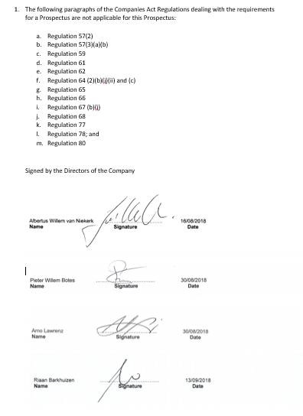

ANNEXURE 1 - Risk Factors
All information in this Prospectus should be considered in light of the risks inherent in high-growth, private equity-style investments.
Investors should note in particular that:
- The shares are illiquid and not listed on any exchange.
- Returns are dependent on successful project execution and counterparty performance under long-term agreements.
- Changes in law, regulation, or policy could materially affect profitability.
- Investments in foreign jurisdictions (e.g., Mozambique JV) expose RBNC to currency and sovereign risk.
- RBNC’s projects are subject to construction, operational, and technological risks that may reduce performance.
Accordingly, this investment should be regarded as high-risk and speculative, and is not suitable for conservative or short-term investors.
The Directors consider the following risks to be material in relation to an investment in Renewable by Nature Capital Limited (‘RBNC’). Prospective investors should carefully consider these factors, together with all other information contained in this Prospectus, before making any investment decision.
 | Description of Risk | Impact on Performance | Level | Mitigating Factors
Economic Conditions | The state of the economy may fluctuate in line with domestic and global cycles, affecting investor confidence and demand for renewable energy projects. | May reduce returns and delay project execution. | Medium | Focus on diversified project portfolio and long-term power purchase agreements (PPAs).
Regulatory & Policy Risk | Changes in legislation, tax policy, renewable energy regulations, or FSCA/FAIS requirements may impact RBNC’s operations and ability to raise capital. | Compliance costs, project delays, or restrictions on activities. | High | Continuous monitoring of regulatory environment, engagement with regulators, and legal compliance reviews.
Liquidity Risk | Shares in RBNC are unlisted and illiquid; investors may struggle to exit their investment early. | Investors may not be able to realise value before maturity; potential capital lock-in. | High | Full upfront disclosure of illiquidity; Board may at its discretion facilitate secondary placements or limited buybacks.
Currency Risk | Exposure to foreign exchange fluctuations on cross-border projects (e.g., Mozambique JV). | FX volatility may erode expected returns on foreign investments. | Medium | Use of hedging instruments and structuring projects in ZAR-linked PPAs where possible.
Operational Risk | Investment decisions or project implementation may be flawed due to inadequate diligence or execution. | Poor project performance, reduced revenues, reputational harm. | Medium | Rigorous due diligence, investment committee oversight, external technical and financial advisors.
Counterparty Risk | Reliance on offtakers, contractors, and JV partners to perform obligations under PPAs, leases, and service agreements. | Default or non-performance may reduce income streams. | High | Counterparty due diligence, credit assessment, contractual protections, and monitoring of performance.
Illiquid Shares | Issued shares are not listed and are illiquid. | Reduced investor exit opportunities. | High | Board disclosure and limited repurchase options at discounted values.
Fraud & Internal Control | Lack of internal audit function could increase exposure to fraud or error. | Financial loss, reputational harm. | Low | Annual external audit, Board-level Audit & Risk Committee oversight.
Credit Risk | Exposure to cash deposits, debtors, and potential gearing. | Loss of capital if counterparties default. | Low | Funds held in reputable banks; conservative credit policies.
Interest Rate Risk | Interest rate fluctuations may impact returns on cash balances or cost of debt. | May reduce profitability or increase financing costs. | Low | Maintain diversified funding sources and cash management policies.
Capital Risk | Risk that RBNC cannot maintain optimal capital structure. | May restrict growth and returns. | Medium | Board may issue new shares or adjust asset allocation to safeguard solvency.

ANNEXURE 2 - Appointment, qualification, remuneration and borrowing powers of directors

The material provisions of the Memorandum of Incorporation of the Company are as follows:

COMPOSITION AND POWERS OF THE BOARD OF DIRECTORS
RETIREMENT OF DIRECTORS
PROCEEDINGS OF DIRECTORS AND COMMITTEES
DIRECTORS’ REMUNERATION

ANNEXURE 3 – Directors service contracts

Name of Director | Commencement Date | Termination Date | Period | Notice Period | Remuneration
Arno Lawrenz | 01/10/2025 | 31/10/2030 | Five consecutive one year terms | 1 calendar month | R 0
Pieter Willem Botes | 01/10/2025 | 31/10/2030 | Five consecutive one year terms | 1 calendar month | R850 000 pa

ANNEXURE 4 – FSCA License

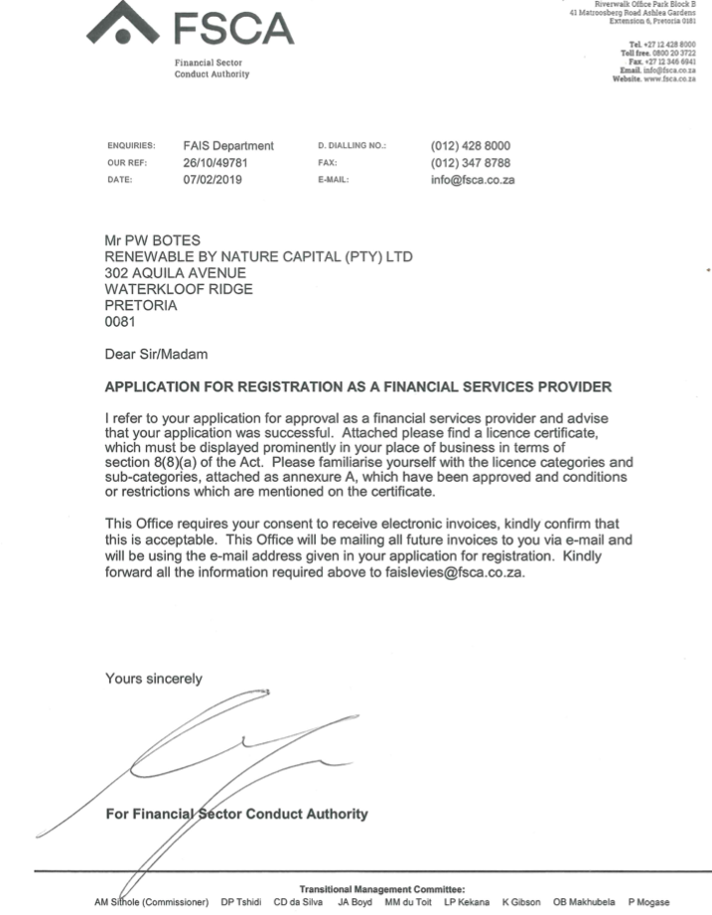
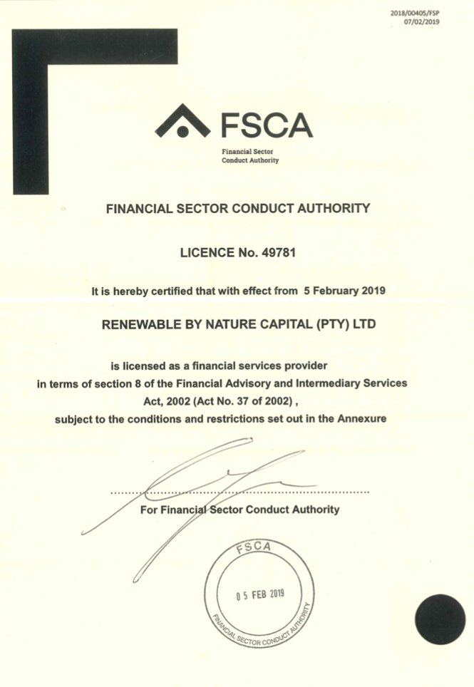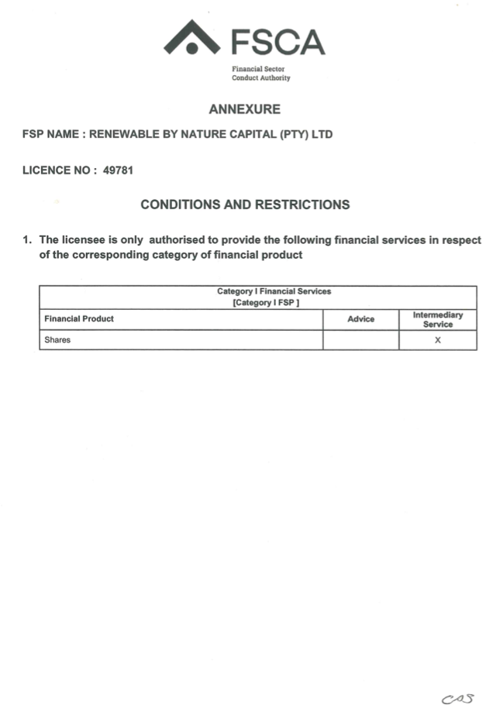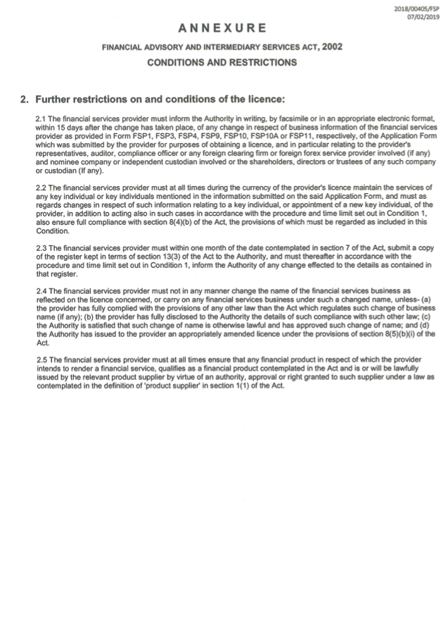

ANNEXURE 5 - King Code on Corporate Governance
Commitment to King IV™
Renewable by Nature Capital Limited (“RBNC”) subscribes to the principles and practices of good corporate governance as set out in the King IV™ Report on Corporate Governance for South Africa (2016). The Board recognises that good governance is fundamental to responsible business conduct, investor confidence, and long-term sustainability.
The Board is committed to the application of King IV’s principles in a manner that is proportionate to the size, resources, and complexity of the Company.

1. Board of Directors
- The Board will consist of an appropriate balance of executive, non-executive, and independent non-executive directors in line with King IV’s recommendations.
- The Chairperson will be an independent non-executive director, separate from the CEO.
- Directors are subject to rotation and re-election at least once every three years in accordance with the Company’s Memorandum of Incorporation (MOI).
- The Board meets quarterly and as required.
Responsibilities of the Board include:
- Setting strategic objectives and overseeing implementation.
- Monitoring financial and non-financial performance.
- Ensuring compliance with all applicable laws, regulations, and codes.
- Governing ethics, risk, technology, and stakeholder relationships.

2. Board Committees
To enhance effectiveness and accountability, the following committees have been established:

a) Audit & Risk Committee
- Composed of a majority of independent non-executive directors.
- Provides assurance on the integrity of financial reporting, effectiveness of internal controls, risk management, and compliance.
- Meets at least twice annually.

b) Remuneration & Nominations Committee
- Oversees fair, responsible, and transparent remuneration practices.
- Ensures that remuneration is aligned to performance and shareholder value creation.
- Reviews Board composition, succession planning, and director appointments.

c) Investment Committee
- Reviews and approves investments in line with RBNC’s mandate.
- Ensures proper due diligence and post-investment monitoring.
- Includes at least one independent non-executive director and an independent external advisor.

3. Risk & Opportunity Governance
- The Board recognises that risk and opportunity are inseparable and must be managed in an integrated way.
- Risk assessments are conducted on all major investment decisions and reported to the Audit & Risk Committee.
- RBNC maintains professional indemnity and fidelity cover as required under FAIS.

4. Ethics & Responsible Corporate Citizenship
- RBNC promotes a culture of integrity, transparency, and fairness in all dealings.
- The Board has approved a Code of Ethics aligned to King IV™ principles.
- The Company is committed to environmental sustainability, social responsibility, and sound governance in all investment activities.

5. Technology & Information Governance
- The Board ensures that technology is appropriately governed to support strategy, manage risk, and safeguard information.
- Cybersecurity and data protection policies are implemented in line with the POPI Act.

6. Stakeholder Relationships
- RBNC is committed to balanced, transparent, and effective stakeholder engagement.
- The interests of shareholders, regulators, employees, and communities are considered in all decisions.
- Shareholders are given equal treatment and timely access to relevant information.

7. Compliance with King IV™
- The Board has performed an assessment of compliance with King IV™ and confirms that RBNC substantially applies all principles of King IV™ appropriate to its scale.
- Any areas of partial application are explained on a “apply and explain” basis as recommended by King IV™.
- There are no material instances of non-compliance with King IV™.

ANNEXURE 6 – FSB Report

